Deadline for entries: Monday 1st June
Application Form

Scottish Civil Engineering Awards 2020
Please complete all sections of this form and submit along with the required materials to cara@cecascotland.co.uk before 5pm on Monday 1st June 2020.
Please read through the application pack before filling in this form and direct any queries by email.

Nominated project details

Name of project
Entry for ‘Engineered in Scotland’ category? | Please indicate yes/no
Local Authority Area (if not for ‘Engineered in Scotland’ category)
Full address of project including postcode
Date of completion
Outturn value

Project team contact details

Lead company/organisation entering the awards

Contact name
Job title
Company/organisation
Company’s role in project | (Client, consultant, designer, contractor etc)
Company address
Phone number
Email
Lead company press office / communications contact:
Name
Job title
Phone number
Email

Deadline for entries: Monday 1st June
Application Form

Names of all key partners (e.g. client, consultants, contractors, architects etc.)

Contact name
Company/organisation
Company’s role in project
Company address
Phone number
Email

Contact name
Company/organisation
Company’s role in project
Company address
Phone number
Email

Contact name
Company/organisation
Company’s role in project
Company address
Phone number
Email

Contact name
Company/organisation
Company’s role in project
Company address
Phone number
Email
Please continue on a seperate page if necessary

Deadline for entries: Monday 1st June
Application Form

Judging criteria
Refer to your application pack for full details.

Guidelines for completing form:
- Image submission
Images should be provided in a high resolution version (minimum 300 dpi)

- Project titles, as a rule, should be concise, in plain English and encapsulate the descriptive aspect of the project.

- On the Executive Summary please avoid:

  - Acronyms

  - Technical descriptions

  - Lengthy titles

Deadline for entries: Monday 1st June
Application Form

Executive summary (250 words maximum)
Strive to:
- use non-technical language
- include five interesting facts about the project
- attach, where possible, a press release about the project
- give a brief synopsis of the project
- emphasise the extent to which the project has transformed peoples’ lives
Please note this section will be used for promotional material and will be public facing.

Deadline for entries: Monday 1st June
Application Form

Project outline

Please explain how the eligibility and judging criteria have been met and highlight any other aspects considered relevant for assessment. Refer to the application pack for full eligibility and criteria guidelines.

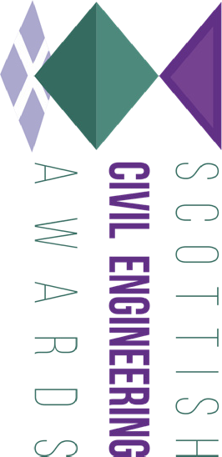
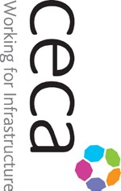
Project outline (cont’d)
Deadline for entries: Monday 1st June
Application Form

Project outline (cont’d)
Deadline for entries: Monday 1st June
Application Form

Deadline for entries: Monday 1st June
Application Form

Conditions of entry

- Entrants must give full details of ALL project team partners (contractors, consultants etc.) and ensure that information provided in the entry is correct and approved as necessary. CECA Scotland and ICE Scotland accepts no responsibility for the publication of inaccurate information supplied with the entry.

- Please note that ICE Scotland and CECA Scotland will use the contact details provided to communicate with project partners as necessary.

- Entry is conditional on entrants agreeing to cooperate with CECA Scotland and ICE Scot- land in obtaining publicity for their schemes, which may include allowing media access to sites and spokespeople.

- Submission of an entry is taken to imply the granting of permission to publish all submitted details and material, including images, of the successful schemes. Material relating to suc- cessful entries will be retained for publicity and archive purposes.

- All images submitted must clearly show copyright and crediting details, otherwise ICE Scot- land and CECA Scotland will assume that none are needed.

- The decisions of the judges in all matters is final. Judges have absolute discretion to reject
any entry which does not comply with the requirements of the rules.

- Feedback on entries will not generally be given except in exceptional cases and at the dis- cretion of the judges.

- By applying for this award, you give permission for CECA Scotland and ICE Scotland to contact you regarding participation in relevant ICE Scotland and CECA Scotland projects and initiatives to showcase inspirational engineering.

Agreement

I declare that I have read, understood and agree to the conditions of entry listed above. Name (print clearly)
Signature

Date

Deadline for entries: Monday 1st June
Application Form

Checklist

Please e-mail the following to 5cara@cecascotland.co.uk before 4pm on 1st June 2020:

- This completed application form

- Six high resolution (300dpi) photographs. Images should include crediting and copyright
information as necessary*

- Supporting information such as layout plan, sketches, drawings (five max)

- Company logos**

- Application fee. Given the CECA and ICE teams are currently working from home, we will phone you after you submit your entry to arrange payment of the fee.

- Project footage including drone, time lapse, BIM collateral will be sought from entrants following submission.

*Six high resolution photographs without company logos, clearly numbered and accompanied
by a list identifying the project and giving a short description.

**Please supply all project team logos as high resolution illustrator, eps, vector or jpeg files and indicate the project team roles (i.e. client, designer, contractor, etc.).

